

Curriculum

Date approved by Governing Body: | July 2026
Date Shared with Staff: | July 2027
Date of Review: | July 2027

Contents

Curriculum Aims

Legislation and guidance

Roles and responsibilities

Organisation and Planning

Inclusion

Monitoring arrangements

Links to other Policies

1. Curriculum Aims
At High Well School, our curriculum is designed to fulfil our ethos of Preparing for Positive Futures.

Our inclusive curriculum ensures that all pupils, regardless of starting point, experience success academically, socially and emotionally. It is designed for pupils with complex Social, Emotional and Mental Health (SEMH) needs and increasingly reflects additional needs including ADHD ASD, speech, language and communication needs, and profiles associated with demand avoidance.

The curriculum aims to:

- Provide a broad, balanced and ambitious curriculum for all pupils.
- Enable pupils to know more, remember more and do more over time.
- Remove barriers to learning through structured, relational and adaptive approaches.
- Develop secure foundations in literacy and numeracy.
- Support emotional regulation, resilience and wellbeing.
- Prepare pupils for further education, employment and independent adulthood.
- Develop positive behaviour for learning and engagement in education.
- Ensure pupils achieve meaningful accreditation and qualifications.
- Promote inclusion, equality and high expectations for all learners.
- Equip pupils with the knowledge, skills and cultural capital to succeed in society
- Provide experiential learning opportunities, enabling pupils to apply knowledge through practical real life and off site contexts.

Our curriculum aims ensure that all pupils, through academic, therapeutic, experiential and futures-focused approaches, overcome barriers to learning, secure knowledge and skills over time, and are fully prepared for positive futures.

2 Legislation and guidance
This policy reflects the statutory requirements for maintained special schools and is underpinned by a commitment to providing a broad, balanced and ambitious curriculum that meets the complex needs of pupils with Social, Emotional and Mental Health (SEMH) needs.
It is informed by the Education Act 2002 and the National Curriculum (2014), which require schools to provide a curriculum that promotes pupils’ spiritual, moral, social, cultural, mental and physical development, adapted appropriately to meet individual needs. At High Well School, the curriculum is purposefully adapted and sequenced to ensure pupils can access learning despite barriers linked to SEMH, speech and language needs, autism, and disrupted educational experiences.
The policy reflects the Children and Families Act 2014 and the SEND Code of Practice (2015), which require schools to deliver individualised, outcomes-focused provision through Education, Health and Care Plans (EHCPs). At High Well, EHCPs are central to curriculum design, ensuring that academic learning is integrated with therapeutic and developmental priorities, enabling pupils to be ready to learn and make sustained progress over time.
In line with the Equality Act 2010, the curriculum ensures equity of access through reasonable adjustments, adaptive teaching and inclusive practice. This is particularly important within an SEMH context, where removing barriers to engagement, participation and success is essential.
This policy also reflects statutory guidance including:
- Relationships, Sex and Health Education (RSHE) (2019), delivered in a way that is developmentally appropriate and sensitive to pupils’ SEMH needs
- Careers guidance (Gatsby Benchmarks), ensuring pupils are prepared for their next stage of education, employment or training
- Keeping Children Safe in Education (KCSIE), ensuring the curriculum actively contributes to pupils’ ability to stay safe and make informed decisions
In addition, this policy reflects current developments from the 2025 Curriculum and Assessment Review, which emphasise:
- Strong foundations in literacy, numeracy and communication
- Clear curriculum sequencing and knowledge progression
- Increased focus on inclusive practice and meeting the needs of all learners
- Greater emphasis on preparation for life, work and adulthood
At High Well School, these principles are implemented through a curriculum that deliberately integrates academic, therapeutic, experiential and futures-focused elements, ensuring that pupils not only access learning but are supported to engage, regulate, achieve and transition successfully to positive futures

3. Roles and responsibilities
3.1 The Governing Body
The governing body will monitor the effectiveness of this policy and hold the Headteacher to account for its implementation, ensuring that the curriculum reflects the school’s ethos of Preparing for Positive Futures and meets the complex needs of pupils with SEMH.
The governing body will ensure that:
- A robust framework is in place for setting curriculum priorities, sequencing and aspirational outcomes for all pupils
- The school provides a broad, balanced and ambitious curriculum, appropriately adapted to meet the needs of pupils with EHCPs
- Sufficient teaching time is allocated to enable pupils to access core subjects, personal development and therapeutic support
- The curriculum promotes pupils’ academic progress, emotional development and preparation for adulthood
- Proper provision is made for pupils with a wide range of needs, including SEMH, autism, speech and language and other additional needs
- All courses leading to qualifications are appropriate, meaningful and aligned to pupils’ abilities and future pathways
- The school implements appropriate assessment systems, recognising small steps of progress as well as academic outcomes
- There is a clear focus on inclusion, equality and removing barriers to learning
- Pupils from Year 7 onwards receive independent, impartial careers guidance, supporting successful transition to post-16 destinations
- The school fulfils its responsibilities in relation to any adaptation or disapplication of the National Curriculum, where appropriate for individual pupils

3.2 The Headteacher
The Headteacher is responsible for ensuring that this policy is fully implemented and that the curriculum is delivered effectively across the school.
The Headteacher will ensure that:
- The curriculum reflects the school’s ethos and is carefully sequenced to support pupils to know more, remember more and do more over time
- All elements of the curriculum, including academic, therapeutic, experiential and futures-focused provision, are coherently planned and meet the needs of all learners
- Curriculum planning is informed by EHCP outcomes, baseline assessments and identified barriers to learning
- Sufficient time is allocated to meet both academic and SEMH needs, ensuring pupils are ready to learn
- Assessment systems are robust, meaningful and compliant with statutory requirements, recognising both academic progress and personal development
- The governing body is fully informed and involved in decisions relating to curriculum design, breadth and balance
- Whole-school priorities, including literacy, sequencing and consistency, are effectively implemented
- High-quality provision is in place for pupils with diverse and complex needs through adaptive teaching and personalised approaches
- Appropriate arrangements are in place regarding withdrawal from curriculum subjects, where relevant

3.3 Subject Leaders
Subject leaders are responsible for the strategic development, implementation and monitoring of their subject areas, ensuring that the curriculum is ambitious, coherently sequenced and accessible for all pupils.
Subject leaders will:
- Design and implement a curriculum that reflects the school’s ethos of Preparing for Positive Futures
- Ensure subject curricula are carefully sequenced and build knowledge and skills over time
- Adapt curriculum content to meet the needs of pupils with SEMH and additional needs, removing barriers to learning
- Embed literacy, communication and key skills within their subject area
- Monitor the quality of teaching and learning through learning walks, work scrutiny and pupil voice
- Use assessment information to identify gaps, inform planning and drive improvement
- Support and develop staff through coaching, modelling and professional development
- Ensure that their subject contributes to pupils’ personal development, independence and preparation for adulthood
- Manage and develop resources to support effective curriculum delivery

3.4 Staff
All staff are responsible for implementing the curriculum in line with this policy.
Staff will:
- Deliver a curriculum that is ambitious, inclusive and responsive to pupils’ needs
- Use adaptive teaching strategies to support pupils with SEMH and additional needs
- Build strong, consistent relationships that support engagement, regulation and learning
- Plan and deliver lessons that are sequenced, purposeful and aligned to curriculum intent
- Use assessment effectively to identify gaps, inform planning and support progress
- Contribute to the development of pupils’ academic achievement, personal development and readiness for adulthood
- Work collaboratively with colleagues and external professionals to ensure that curriculum delivery reflects EHCP outcomes and personalised provision

4. Organisation and planning
At High Well School, we recognise that in order for pupils to achieve success, they must first be ready to learn. For many of our pupils, Social, Emotional and Mental Health (SEMH) needs present the greatest barriers to engagement, participation and progress. Our curriculum is therefore designed to explicitly address these barriers through a nurture-based, trauma-informed approach.

Our practice is rooted in the Six Principles of Nurture, recognising the significant impact of early childhood experiences and trauma on development. We prioritise the development of strong, consistent and trusting relationships, as these provide the foundation for engagement, regulation and learning.

Many pupils join High Well following disrupted or negative experiences of education, and re-engaging them in learning is a fundamental priority. Through our curriculum, we aim to inspire pupils by creating a positive, inclusive and supportive learning environment where success is achievable and celebrated. This underpins all aspects of curriculum organisation and planning.

At High Well School, the curriculum is carefully organised and planned to ensure that pupils know more, remember more and are able to do more over time, enabling sustained progress from individual starting points.
The curriculum is coherently sequenced and cumulatively built, ensuring that knowledge, skills and behaviours develop over time. Planning explicitly addresses the social, emotional and cognitive barriers to learning, ensuring all pupils can access and engage successfully in education.

Our curriculum is underpinned by four key pillars: Academic, Therapeutic, Experiential and Preparing for Positive Futures. Together, these pillars create a holistic and highly personalised curriculum that meets the complex needs of our pupils.

Academic Pillar
We provide a broad, balanced and ambitious academic curriculum that:
- Builds secure foundations in literacy and numeracy
- Ensures pupils develop knowledge and skills progressively over time
- Embeds reading, vocabulary and communication across all subjects
- Addresses gaps in learning through structured and sequenced teaching
- Supports pupils to achieve meaningful accreditation and qualifications

Therapeutic Pillar
We recognise that learning is dependent on emotional readiness, and therefore:
- Develop emotional literacy, self-regulation and resilience
- Provide consistent, relational and nurturing environments
- Use EHCP outcomes, Boxall profiles and targeted interventions to remove barriers
- Support pupils to build positive relationships and behaviours for learning
- Provide structured opportunities for success, helping pupils rebuild confidence

Experiential Pillar
We ensure pupils can apply their learning in meaningful contexts by:
- Providing hands-on, practical and off-site learning experiences
- Creating opportunities for pupils to apply knowledge in real-life situations
- Supporting the development of independence, problem-solving and teamwork
- Enhancing engagement through active and purposeful learning opportunities

Preparing for Positive Futures Pillar
We prepare pupils for life beyond school by:
- Developing independence and life skills
- Providing careers education, guidance and work-related learning
- Supporting pupils to understand and work towards their aspirations and destinations
- Equipping pupils with the knowledge, skills and cultural capital required for adulthood

All curriculum decisions are driven by:
- Individual starting points and baseline assessment
- EHCP outcomes and personalised targets
- Identified gaps in knowledge, skills and learning behaviours
- Pupils’ long-term aspirations and intended destinations

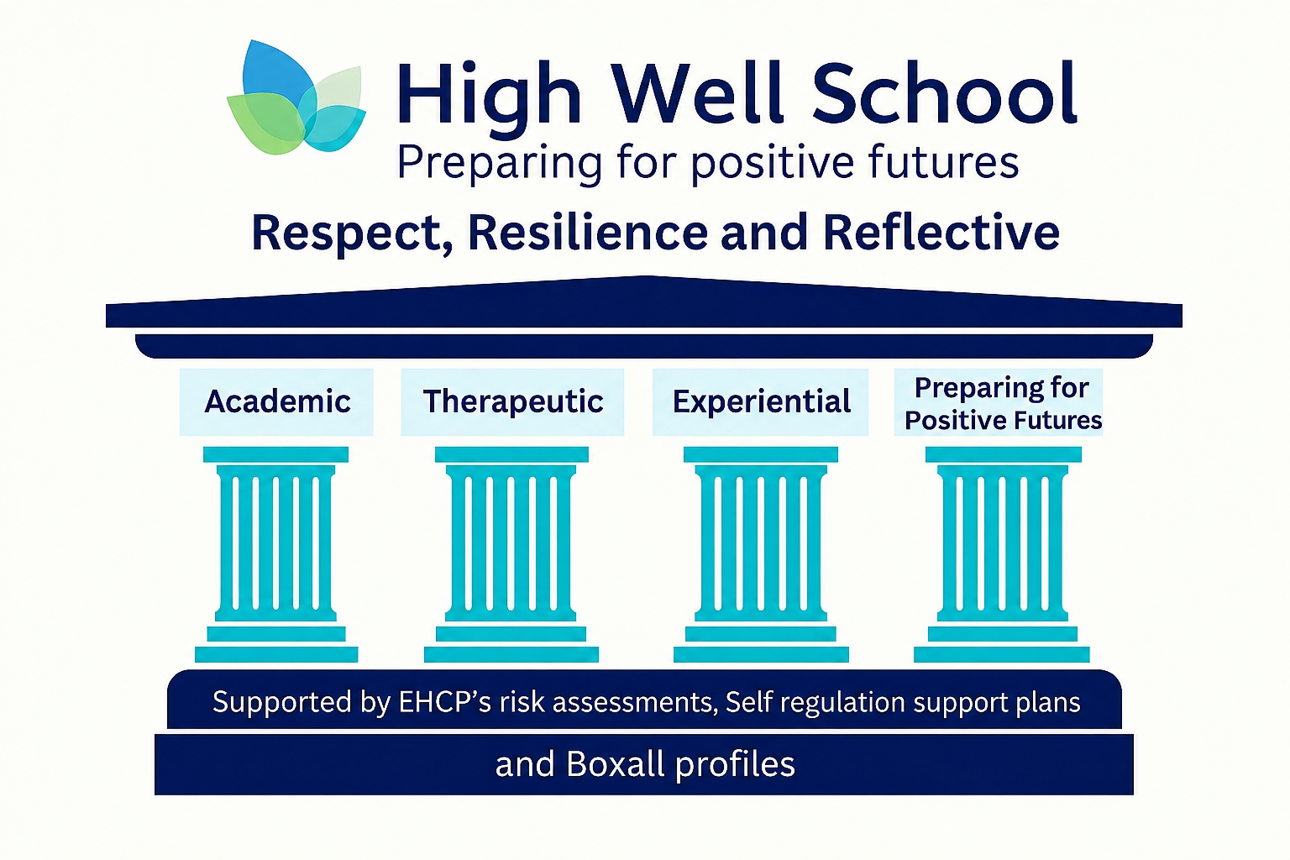
The structure of our curriculum is illustrated in the diagram above. This model demonstrates how the four core pillars — Academic, Therapeutic, Experiential and Preparing for Positive Futures — work together to provide a holistic, balanced and highly personalised curriculum for all pupils.
These pillars are underpinned by a range of personalised frameworks and our four core curriculum principles, ensuring that the curriculum is ambitious, inclusive and responsive, and that all pupils are able to engage, achieve and make sustained progress.

5. Inclusion

Personalisation and inclusion is central to curriculum planning and delivery, and is informed by:
- Individual starting points
- Education, Health and Care Plans (EHCPs)
- Boxall Profiles
- Self-Regulation Support Plans
- Risk Assessments
- Speech and Language Therapy guidance
- Occupational Therapy guidance
- Educational Psychology advice

These personalised approaches are operationalised through four core principles:
We Have High Aspiration
We believe that all pupils can succeed when teaching is structured, supportive and ambitious.
- Curriculum content is carefully sequenced
- Pupils access appropriate challenge from their starting points
- Learning builds cumulatively over time
- Qualifications and pathways reflect individual potential

We Prioritise Relationships and Regulation
We recognise that emotional safety is a prerequisite for learning.
- Stable, consistent adult relationships underpin curriculum delivery
- Predictable routines reduce anxiety and cognitive load
- Regulation strategies are explicitly taught and embedded
- Trauma-informed approaches support engagement, participation and readiness to learn

We Develop Independence
We prepare pupils for life beyond school by building autonomy and independence.
- Self-regulation and emotional literacy are explicitly taught
- Pupils develop problem-solving and decision-making skills
- Independent learning behaviours are systematically developed
- Pupils take increasing responsibility for their learning

We Ensure No Learner is Left Behind
The curriculum is adaptive, inclusive and responsive, ensuring all pupils can access learning and succeed.
- Planning and delivery are tailored to individual need
- Barriers to learning are identified and systematically addressed
- Support is informed by multi-agency assessment and guidance
- All pupils are enabled to make progress from their starting points

6. Monitoring

Curriculum delivery at High Well School is monitored through a robust and systematic approach involving governors, senior leaders and subject leaders. The governing body provides strategic oversight by receiving regular reports on curriculum effectiveness, pupil outcomes and the quality of provision, and through focused governor visits and challenge meetings. Senior leaders carry out regular quality assurance activities across the school, including learning walks, book scrutinies, data analysis and pupil voice, to evaluate how effectively the curriculum is implemented and to identify areas for improvement. Subject leaders monitor their specific areas through regular review of planning, teaching and assessment, ensuring that sequencing, challenge and adaptation meet the needs of all pupils, particularly those with SEMH and additional needs. Findings from all monitoring activities are shared and acted upon through the school improvement cycle, ensuring continuous development, consistency of practice and alignment with the school’s curriculum intent and ethos of Preparing for Positive Futures.

