

Attendance Policy

Date approved by Governing Body: | November 2025
Date of Review: | November 2026

Contents

- Policy Statement and Aims 3

- Attendance and Punctuality 3

- The Attendance Team 3

- Attendance and Punctuality Procedures 5

- Strategies for promoting attendance 5

- Absconding from school 6

- Holidays in term time 7

- Policy Review 8

Appendix 1 – Attendance Flowchart 10

Appendix 2 – Holiday / Leave for Absence Request Form 13

1. Policy Statement and Aims
All staff at High Well School will work with pupils and their families to ensure that each pupil attends school regularly and minimise absence of any kind. Good attendance and punctuality is an essential life skill and we recognise that by being in school we are able to support pupils in achieving the school ethos of, Preparing for Positive Futures. Improving attendance is a key priority for High Well and we will achieve this through:
- Raising awareness of the effects of absence and lateness
- Promoting good attendance
- Reducing absence, including persistent and severe absence
- Ensuring effective systems are in place to monitor absence and to identify and address any underlying barriers that pupils and their families face
- Acting early to address patterns of absence
- Building strong relationships with families to ensure pupils have the support in place to attend school
- Reviewing and enhancing systems for recognising and rewarding pupils who improve their attendance
- Working with pupils and parents/carers and other agencies to ensure a high priority is given to good attendance to avoid persistent levels of absence/ lateness

2. Attendance and Punctuality
OFSTED regulate and inspect all schools and academies in order to achieve excellence in the care of young people in education. They regularly collate and analyse data regarding attendance from all education establishments.

The Department for Education (DfE) guidelines state that it is the responsibility of parents/carers to ensure their children attend school regularly. At High Well School each pupil’s attendance is regularly monitored and the school will work closely with families and other agencies to promote good attendance.

Effective education can only take place if a pupil attends regularly. At High Well School our ethos interlinks good attendance and punctuality and we are committed to working in partnership with families to ensure that pupils arrive at school on time and ready for the day ahead taking into account the challenges that our pupils and families face.

3. The Attendance Team
The Family Liaison/Attendance Officer (Vanessa Robinson) will contact parents/carers by phone or text where a pupil is absent and the school has not received any notification regarding the absence. This is in line with our attendance process and part of out first response check ins. Any late arrivals and punctuality issues will be discussed on the day with pupils and if necessary parents/carers.

The Education Welfare Officer (EWO) works as a link between home, school other agencies and the Local Authority, in order to address attendance issues and ensure that all pupils are receiving a full-time education. This involves explaining to parents/carers their legal responsibilities, referring to other agencies and encouraging families to build good relationships with school. The EWO may conduct home visits with the school’s Family Liaison/Attendance Officer and may work with other agencies.
- Please refer to Attendance process plan flow chart – Appendix 1

4. Attendance Procedures
High Well School has a responsibility to reduce the number of pupils whose attendance is below 90% over the school year. This adds up to missing almost half a term. High Well school applies the following procedures in how to deal with individual absences:

  - Pupils should arrive in school from 8.45am with registration from 9.00am to 9.15am
  - Pupils missing from registration will be marked as absent and the first day response will take place before 10am by the Administrative Team and/or Family Liaison/Attendance Officer
  - If a pupil is unable to attend school parents/carers should contact the school on 01924 572100 to explain the reason for absence. This should be done everyday a pupil is absent.
  - Pupils arriving after 9.15am without a valid reason will be marked as late in the register.
  - Any pupil who does not attend school without a valid reason will be marked as ‘O’ in the register (unauthorised absence).
  - If a parent/carer does not respond to the reason for absence, a further phone call, text message and/or email will be made on the same day. School staff will also follow up with the second contact for a pupil, if there is no response from parent/carer or other agencies who may be involved with the family, including social worker, early help worker etc.
  - Pupils who present with additional vulnerabilities such as CiC, CP, CiN will be prioritised for a home visit on the same day, if contact cannot be established through social workers/other professionals.
  - Any pupil who does not attend for two consecutive days without contact from parents/carers to the school will be visited at home on day 2 to establish the reason for absence and carry out a welfare check.
  - If no contact can be made on a visit on day 2, High Well will escalate to Education Welfare and Social Care so that safety of the pupil can be established.
  - High Well School can also request a welfare check is undertaken by West Yorkshire Police if there are concerns about absence and communication. This is in line with our Safeguarding Policy.
  - Our aim is to have open communication between school and parents. If this isn’t the case then the Education Welfare Officer, as well as other agencies, may become involved and will arrange a face to face meeting in school.

Arriving on time and ready to learn

High Well School is committed to ensuring all pupils arrive on time, in uniform and ready to start their day. Pupils who arrive late to school will be marked as late in the register. We understand that there will be occasions when there are valid reasons and the school are committed to supporting pupils and families on these occasions. High Well School is an Operation Encompass School and provides support to pupils the next day following any notification of a domestic abuse incident in the family home.
A pupil’s attendance is discussed at a ITAC (Internal Team around the child) meeting where school staff focus on attendance, EHCP outcomes, Risk Assessments and wider offer.
Letters Home

Letters are sent to parents/carers at the end of each half term, term and at the end of the academic year, these letters contain a copy of the child’s attendance certificate and information explaining their child attendance percentage. In each letter parents/carers are encouraged to call the Family Liaison/Attendance Officer to discuss any barriers to attendance and to work with families and support them. We are here to support pupils and families and are committed to work together to improve and maintain good attendance for every child at High Well School.

Attendance Concern Meetings

Our Family Liaison/Attendance Officer analyses school attendance data daily. If a decline in attendance is noticed and/or if a pattern has been seen to arise the Family Liaison/Attendance Officer will invite parents/carers and if appropriate the pupil to an informal meeting to discuss the concerns and offer support. Any actions from these meetings will be discussed with SLT, EWO (Education Welfare Officer) and any interventions/support can then be put in place for pupils and families.

Persistent Absence – Fast Track Meetings

If a pupil’s attendance falls below 90% this pupil is classified as ‘Persistently Absent’. A pattern of attendance approaching or falling below 90% will trigger involvement from the school’s Education Welfare Officer (EWO). A meeting will be scheduled with parents/carers with the EWO and High Well’s Attendance Officer. This will provide an opportunity to discuss barriers to good attendance and identify strategies/support which the school could provide to improve attendance. In these meetings together, support could be offered or are referred to other agencies. A plan is drawn up and a timescale of which we wish to see improvement is agreed by all. A letter outlining the agreement is sent to parents and any other involved agencies.

Where concerns exist, parents/carers will also be made aware of the possible actions if the pupil were to remain ‘Persistently Absent’. It is important to note that High Well does take into account genuine reasons for absence including illness, family bereavement, regular medical appointments or other issues that may lead to attendance falling below 90%. We understand that some pupils will have physical and mental health needs and we are committed to supporting pupils and their families to receive appropriate support.

Severely Absent

Pupils whose attendance is 50% or below (missing at least half of their education) is classed as severely absent and this will trigger a meeting with the Family Liaison/Attendance Office and SLT. In addition, permission will be sought from parents/carers to discuss their child’s attendance at our monthly Team Around the School (TAS) Meetings. This will allow a multi-agency response to support the family in improving their child’s attendance.

As a specialist SEND school, High Well has a limited number of places available. Pupils who are persistently absent or severely absent are unable to benefit fully from the specialist education offer that can have a huge impact on their lives and opportunities for their futures.

Home to School transport

Most pupils at High Well School are transported to and from school by Wakefield’s Home to School transport service. Consideration may be given to the removal of this service for pupils who are persistently absent or severely absent with responsibility for transporting to and from school transferring to parent/carers. It is extremely important that every child attends school every day.

Penalty Notice

If all support and interventions are unsuccessful, High Well School may take the decision to discuss a child’s absence with the EWO, where there is prolonged ‘Persistent Absence’. We will do everything we can as a school to resolve and promote working with families before any penalties are given. This process can involve an initial Penalty Notice arising from any of the following circumstances:

- No improvements following Fast track review meeting or other meetings regarding attendance.
- Attendance falls below 90%
- Inappropriate condoned parental absence
- Unauthorised term time holidays
- Persistent late arrival to school
- Truancy or absconding from school
- A minimum of 10 school sessions lost to unauthorised absence

The cost of the penalty notice is £80 per parent/carer, per child if paid within 21 days of the receipt of the Notice, increasing to £160 if paid after 21 days but within 28 days of receipt of the notice. If the Local Authority does not receive payment they may then progress the matter to the Magistrates Court. High Well School does not receive any monies attributed to the penalty notice.

Parental Prosecution

High Well School work closely to support families in an attempt to avoid legal proceedings however parents/carers are legally responsible for ensuring their child receives a full-time education. Failure to do so may lead to a parental prosecution in the Magistrates Court and the possibility of receiving a Parenting Order or a fine up to £2,500 or a prison sentence for each parent/carer.

Prosecutions at this level would only be sought in exceptional circumstances, where the school felt all strategies had been used in seeking to improve attendance and that parents/carers were not cooperating.

Education Supervision Order

An Education Supervision Order can be used in order to work with families and schools, often with the support of external agencies, to secure a return to regular attendance. An application to secure an Education Supervision Order is heard by the Family Proceedings Court, a process which happens outside of school.

5. Strategies for Promoting Attendance
High Well School seeks to reward students for good attendance and have implemented a reward system to do this. Our rewards system will recognise improvements on an individual basis.
Weekly
Every pupil who achieves 100% attendance is awarded a certificate in assembly and a small treat for them to take home. Parents/carers are sent a positive message home to pass on our congratulations to the child and thank the parent/carer for their continued support. We will also ensure that improvements made after attendance meetings are recognised through communication with pupil and families.
Half-Termly
At the end of each half term, school will host an afternoon treat in the dining hall, students with 95% attendance or those with a significant improvement in their attendance will be invited to celebrate their achievement with ice-cream and music.
Termly
Every pupil who achieves 95% attendance will be invited for an off-site reward. Every pupil who achieves 100% attendance will be entered for a prize draw.
Specific Targeted Rewards
Where we wish to see an individual improvement in attendance the Family Liaison/Attendance Officer will speak with the pupil and together they will decide upon a specific targeted reward to engage them.
Where pupils have unauthorised absences from school due to school refusal, school will encourage parents to implement consequences at home to see if this can deter unauthorised absence in the future. If parents are unable to put in place consequences at home to support improving attendance, the schools identify any specific support needs for parent. The school will seek advice from other agencies including Social Care.

6. Absconding from School
When a pupil has left the school site without permission, school will promptly notify parents/carers about the situation. High Well School staff will attempt to keep a visual of pupils who have absconded but if they lose sight then a call will be made to 101 to inform the police. If a Parent/Carer cannot be contacted, the school will make a report to 101 Police to report the child as missing. Pupils who abscond from the school site will be marked as unauthorised absence in the register. A meeting will need to happen regarding the reasons for the absconding/behaviours displayed and how school staff can best support.

7. Holidays in Term Time
Families who would like to take their child on holiday during term time should be aware that the law does not grant parents an automatic right to take their child out of school during term time.

Whilst it might be considered that a holiday will be educational, pupils will still miss out on the teaching that they would normally have received during the holiday.

The DfE allows a Headteacher the discretion to consider authorising a holiday in term time only in “exceptional circumstances”. If you consider that your request for a holiday is exceptional you will need to write to the school explaining your circumstances. The request will be given full consideration with a response provided as soon as possible. If the holiday is not considered to meet the criteria for exceptional circumstances, and the holiday is still taken in term time, the absence will be recorded as unauthorised and a Penalty Notice issued.

Please note that from the 19th August 2024 the Penalty notice criteria has changed to be inline with the DofE framework.
A Penalty is issued to each parent/carer for each child taken out of school. The cost of the penalty notice is £80 per parent/carer, per child if paid within 21 days of the receipt of the Notice, increasing to £160 if paid after 21 days but within 28 days of receipt of the notice. If the Local Authority does not receive payment they may then progress the matter to the Magistrates Court. High Well School does not receive any monies attributed to the penalty notice.

All holiday request forms must be completed by the parent/carer who resides with the pupil and submitted to the school at least 4 weeks prior to the start of the holiday to the Family Liaison/Attendance Officer.

When considering the decision whether to authorise, the following factors will be taken into account:
- Reasons given for the holiday
- The time of the year/term
- Whether the pupil would miss any preparation for examinations/tests
- Whether the pupil would miss any examinations/tests
- The previous attendance/punctuality record of the pupil

As guidance for parents/carers it is important to note that holidays will not be authorised for the following reasons:

- Availability of cheap holidays
- Availability of the desired accommodation
- Holidays booked as surprises by family members
- Poor weather experienced in school holiday periods
- Overlap with the beginning or end of term
- Only time available due to work (unless documentation is provided by employers which clearly states restrictions)
- Holidays will not be authorised in any circumstances during formal examination periods

Any exceptional request for holiday absence will be considered very carefully.

8. Policy Review

This policy will be reviewed by the school and Governing Board annually or in light of any relevant changes to legislation.

Appendix 1

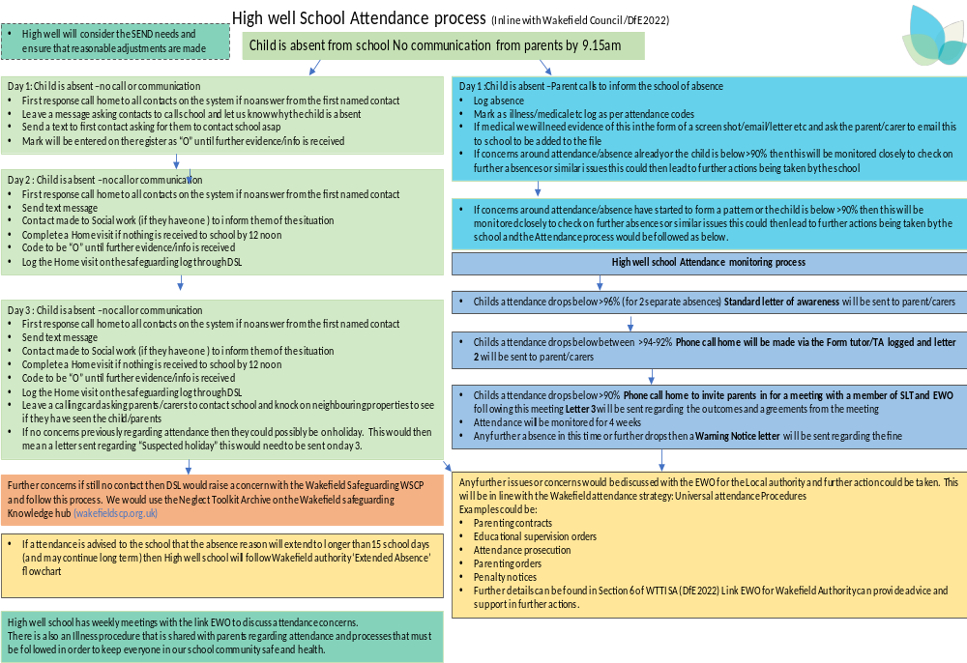

Appendix 2
Leave of Absence Request Form

Taking your child on holiday in term time can be disruptive to both the child’s learning and to the school. The school is only able to consider holidays in term time where both:

- The application is made to the Headteacher 4 weeks in advance of the holiday by a parent the child normally lives with.
- There are exceptional circumstances.

Applications should be made as far in advance of the holiday as possible and you should speak to the class teacher before you book.

High Well School will not ordinarily grant permission for leave of absence for holidays during term time. Families can expect to receive a penalty notice if they choose to take children out of school without permission from the Headteacher. The penalty is currently £80 per parent, per child. If the penalty notice is not paid within 21 days, the amount will rise to £160 per parent, per child.

However, if you feel that there are exceptional circumstances around the holiday request, please submit your reasons in writing in the space below.

Name of Child | Class | Dates To/From | Reason for leave of Absence request

Total number of days not including weekends / Holidays / Inset Days:

Parent / Carer Signature:_____________________________________________

Date:_____________________________________________________________

FOR OFFICE USE ONLY
Attendance year to date:
Authorised year to date:
Unauthorised year to date:
Absence classed as:
Headteacher Signature:
Date:
Copy to Parent / Carer:

