School Immunisation Team
Tuscany Way
Normanton
WF6 2UA

Tel: 01924 310133

Dear Parent/Guardian,
Year 8 – Human Papillomavirus (HPV)

It is now time for your child to have their HPV immunisation to give them long term protection against the HPV virus. For further information click or search this link:

HPV vaccine - NHS (www.nhs.uk)
How do you let us know you want your child to have the HPV vaccination ?

Please fill in one online consent form for each child by clicking or searching the following link or scan the QR code


HPV Vaccination Consent Form (wakefieldschoolimmunisations.co.uk)

The code for your child’s school is: WF131526
Important:
Please fill the online consent in as soon as you can to ensure your child gets vaccinated.
Even if you do not want your child to be vaccinated, please complete the form to let us know.

The session will be in school on Friday 21st March access to the link will close 3 days before the session.
What if my child is absent or refuses?
We hold catch up sessions in school throughout the year where we will attempt to see your child again. Alternatively, clinic invitations may be sent.
Call us on 01924 310133 if you have any problems completing the form or any questions. The team will be happy to help.
Yours sincerely,
School Aged Immunisation Service
Our website:
School immunisations - Wakefield - Better Lives Healthy Futures (betterliveshealthyfuturesbw.nhs.uk)


Important information about your child’s health
Protecting your child against serious diseases
Dear Parent/Carer,

All children in Year 8 are offered the
Human Papillomavirus (HPV) vaccine
This helps to protect against the HPV virus which can cause certain cancers.

Please complete your form as soon as possible.
IMPORTANT: Complete the ‘refusal section’ of the form if you do not want your child to receive the vaccination
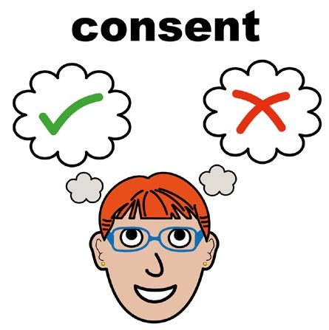


Go to the following website:
https://www.wakefieldschoolimmunisations.co.uk/Forms/HPV


When you log on, enter the code for your child’s school which can be found on the first page of this lettter.
Once you have entered your email address and school code, continue to enter your child’s details.


If you are experiencing problems with this then please contact the Wakefield School Immunisation Team on 01924 310133 and a member of staff will be happy to help you and answer any of your queries.

You will receive a confirmation email to inform you of when your child has received their immunisation.

