School Immunisation Team

Tuscany Way

Normanton

WF6 2UA

Tel: 01924 310133

Dear parent/guardian,

**Year 9** **- Diphtheria, Tetanus, Polio, Meningitis ACWY and Measles/Mumps/Rubella**

It is now time for your child to have their teenage immunisations to give them long term protection against the diseases listed above. For further information click or search this link: <https://assets.publishing.service.gov.uk/media/6405e7ae8fa8f527fb67cb6a/UKHSA-12287-immunisations-young-people.pdf>

**How do I consent for these vaccinations?**

Please fill in one online consent form for each child, **click or search the following link**:

<https://www.wakefieldschoolimmunisations.co.uk/Forms/DTP>

The code for your child’s school is: WF131526

**Important: Please fill the online consent in as soon as you can to ensure your child gets vaccinated.**

**Even if you do not want your child to be vaccinated, please complete the form to let us know.**

**The session will be in school on Friday 21st March access to the link will close 3 days before the session.**

**What if my child is absent or refuses?**

**We hold catch up sessions in school throughout the year where we will attempt to see your child again. Alternatively, clinic invitations may be sent.**

**We also include the opportunity to consent for the MMR vaccination/s if your child is not up to date. Your child should have received 2 doses to be fully protected. If you’re unsure we recommend you give consent, and we will check your child’s health record prior to vaccination.**

Call us on **01924 310133** if you have any problems or questions. The team will be happy to help.

**Yours sincerely,**

**School Aged Immunisation Service**





**Important information about your child’s health**

**Protecting your child against serious diseases**

**Dear Parent/Carer,**

**IMPORTANT:** If you do not wish your child to receive the vaccination, it is still important that you complete the **‘refusal section’** on the form so that we understand your wishes.

**Please complete your form as soon as possible.**

Your child may also be offered the **Measles, Mumps and Rubella (MMR)** vaccine, if they have missed this when they were younger.

**All children in Year 9 are offered:**

1. **Meningitis ACWY vaccine** – This helps to protect against meningitis and septicaemia.
2. **Diptheria, Tetanus and Polio (DTP)** – teenage booster.

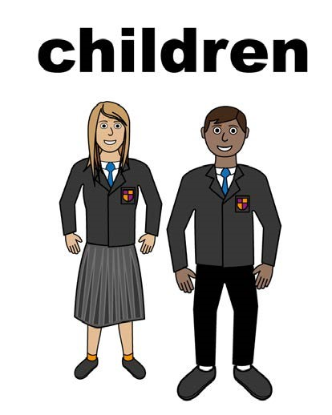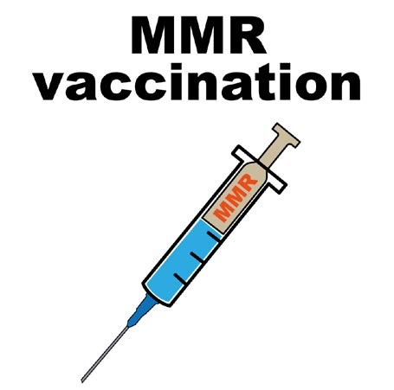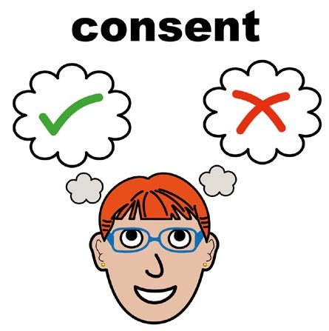

**How to give consent**

**You will receive a confirmation email to inform you of when your child has received their immunisation.**

If you are experiencing problems with this then **please contact the immunisation team on** **01924 310133**, and a member of staff will be happy to help you and answer any of your queries.

When you log on, enter the code for your child’s school. This will have been provided to you by school.

Once you have entered your email address and school code, continue to enter your child’s details.

**Go to the following website:** [School immunisations - Wakefield - Better Lives Healthy Futures (betterliveshealthyfuturesbw.nhs.uk)](https://www.betterliveshealthyfuturesbw.nhs.uk/learning_resource/school-immunisations-wakefield/)

